Data Structure Searching Algorithms assignments

Mandatory

- Refer the code in “Binary Search” in socodery folder. Modify the existing implementation to include the following operations.
  - Read lines instead of words
  - Sort the remaining lines
  - Search for a line and if found delete the line
  - Final list of lines after above operations to be written to a file out.txt
Add required functions
Test with dataset below
Line 9- 90 words
Line 2 - 89 words
Line 7-45 words
Line 3 -45 words
Line 4 -45 words
Line 3 -45 words
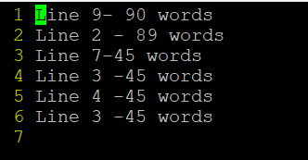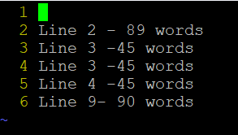
Input.txt output.txt

